Essential Systems

Krysta Albertson, Jordan Gates, Andrew Huff, Adam Passanisi, William Phelps, Louis Ries

Elaboration Specification

May 2nd, 2017

The Race to a New System

The Kentucky Horsemen Benevolence and Protective Association have given us some issues they have found in their current system.  A system requirement is a statement of what a system must do or what characteristics it needs to have to fulfill a business process. Some of the requirements of this particular system will help the KHBPA to improve efficiency in their business processes.

**System Requirements:**

Donations shall be able to be received online.

Reports shall be able to be requested online.

Reports shall be able to be paid for online.

Benefit forms shall be online for members to view in a documents gallery.

The KHBPA shall be able to poll members online.

The website shall drive traffic using social media links.

The system shall have a disaster recovery plan.

The system shall allow for backups.

The website shall allow users to sign up for a membership online.

The website shall have a member log in page for members to access their accounts.

The website shall have a method for allowing events to get feedback.

The website shall allow users to submit forms.

The website shall have a calendar to show upcoming events.

The website shall allow members or users to upload photos directly to the website.

The website shall have a photo gallery.

The website shall allow the KHBPA to send electronic newsletters.

The website shall allow newsletter signup requests to be submitted.

The website shall have a contact us section for viewers to send questions to the KHBPA.

The website shall be mobile friendly so that users without a computer can easily navigate the website.

The website shall allow for an admin to manage user accounts.

The website shall allow for employees of the KHBPA information to be shown for contact purposes.

**Use Case Diagrams:**

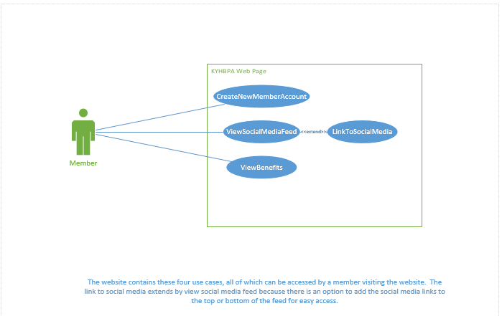

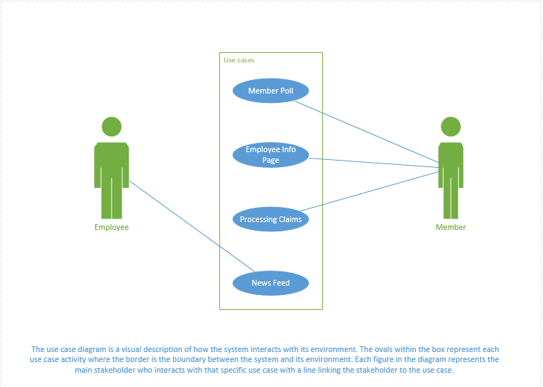

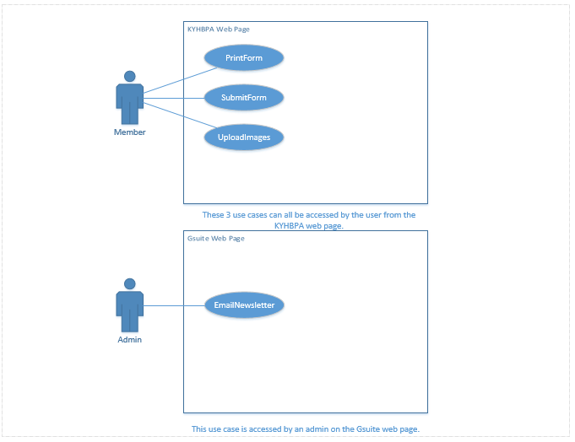

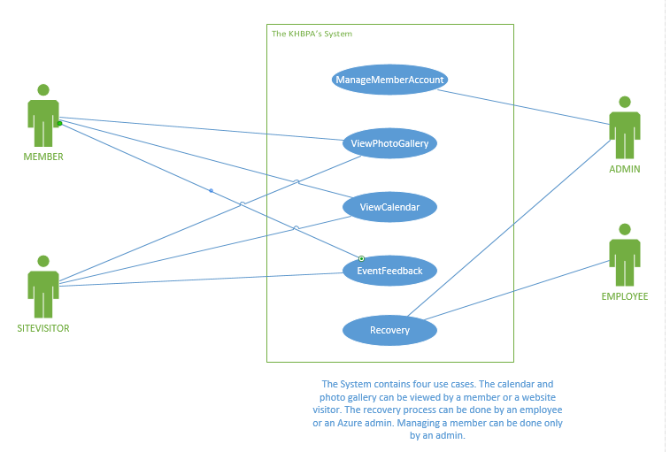

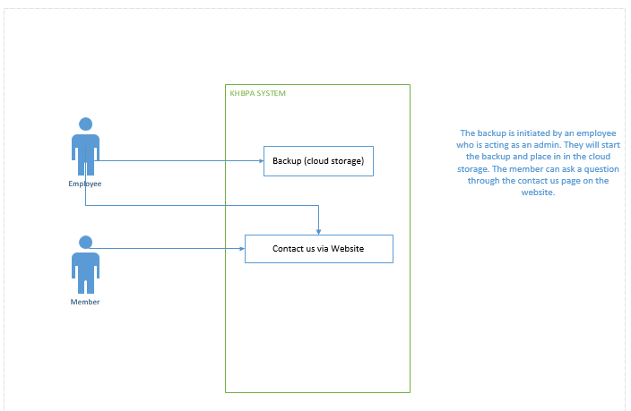

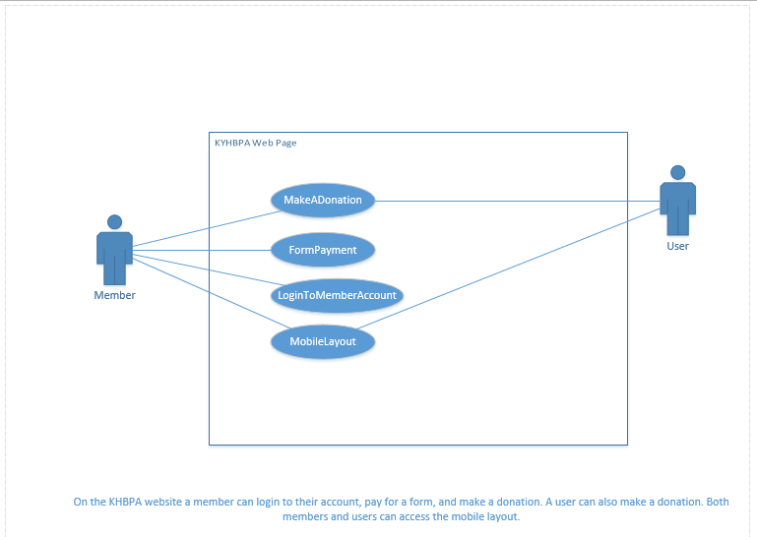

**Trace Matrix:**

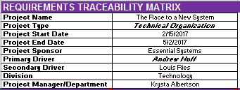

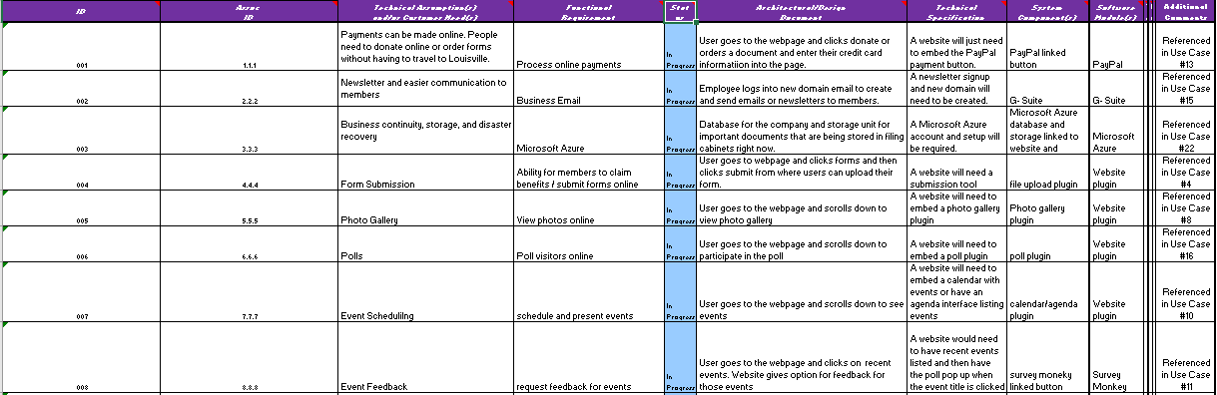

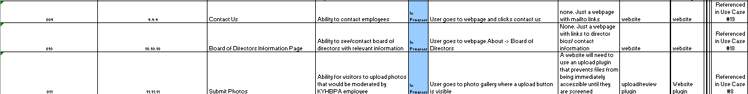

The Traceability matrix has an id column and an associated id column to show which use case is related to which requirement of the system. The last column is comments for the matrix. That is where we wrote “referenced use case #” to make the matrix easier to understand.

|  |  |  |  |  |  |  |  |  |  |  |  |
| --- | --- | --- | --- | --- | --- | --- | --- | --- | --- | --- | --- |
|  |  |  |  |  |  |  |  |  |  |  |  |
|  |  |  |  |  |  |  |  |  |  |  |  |
|  |  |  |  |  |  |  |  |  |  |  |  |
|  |  |  |  |  |  |  |  |  |  |  |  |
|  |  |  |  |  |  |  |  |  |  |  |  |
|  |  |  |  |  |  |  |  |  |  |  |  |
|  |  |  |  |  |  |  |  |  | | |  |
|  | | | | | |  |  |  | | | |

Use Case Specification: CreateNewMemberAccount

Version 1.1

Revision History

|  |  |  |  |
| --- | --- | --- | --- |
| **Date** | **Version** | **Description** | **Author** |
| 01/03/17 | 1.0 | Use Case for New Member Account | Andrew Huff |
| 05/04/17 | 1.1 | Use Case for New Member Account | Andrew Huff |
|  |  |  |  |
| 1 |  |  |  |

Table of Contents

1. CreateNewMemberAccount 14

1.1 Brief Description 14

2. Flow of Events 14

2.1 Basic Flow 14

2.2 Alternative Flows 15

2.2.1 Invalid Email Address 15

2.2.2 Invalid Password 15

2.2.3 Cancel 15

3. Special Requirements 16

3.1 None 16

4. Pre-conditions 16

4.1 A member clicks on the register button on the KY HBPA homepage. 16

5. Post-conditions 16

5.1 A member account is created for the member. 16

5.2 A member cancels the account creation process. 16

Use Case Specification: CreateNewMemberAccount

# Use-Case Name

## Brief Description

The system creates a new account for a member. The member provides the necessary registration details required by the KY HBPA including name, stable name, managing partner, address, phone, membership type and KRC license number.

# Flow of Events

## Basic Flow

1. The use case begins when the member selects “Register”.
2. While the customer details are invalid:
   1. The system asks the member for the required details consisting of:
      * an e-mail address
      * Password
      * password confirmation
      * stable name
      * Address
      * phone number
      * membership type
      * KRC license number.
   2. The system validates the member’s details.
3. The system creates a new account for the member.

## Alternative Flows

### Invalid Email Address

#### The alternative flow begins in step 2.2 of the main flow.

#### The system informs the member that he or she entered an invalid e-mail address.

### Invalid Password

#### The alternative flow begins in step 2.2 of the main flow.

#### The system informs the member that he or she entered an invalid password.

### Cancel

#### The alternative flow begins at any time.

2. The member backs out of the registration page

# Special Requirements

## None

# Pre-conditions

## A member clicks on the register button on the KY HBPA homepage.

# Post-conditions

## A member account is created for the member.

## A member cancels the account creation process.

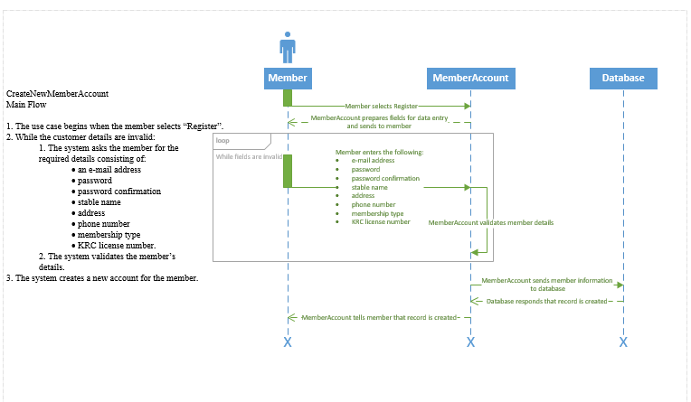

Use Case Specification: LoginToMemberAccount

Version 1.1

Revision History

|  |  |  |  |
| --- | --- | --- | --- |
| **Date** | **Version** | **Description** | **Author** |
| 01/03/17 | 1.0 | Use Case for Member Account Login | Louis Ries |
| 05/04/17 | 1.1 | Use Case for Member Account Login | Louis Ries |
|  |  |  |  |
| 2 |  |  |  |

Table of Contents

1. LoginToMemberAccount 21

1.1 Brief Description 21

2. Flow of Events 21

2.1 Basic Flow 21

2.2 Alternative Flows 21

2.2.1 Invalid Email Address / Password 21

3. Special Requirements 22

3.1 None 22

4. Pre-conditions 22

4.1 A member clicks on the login button on the KY HBPA homepage. 22

5. Post-conditions 22

5.1 A member is logged into their account. 22

5.2 A member receives a bad e-mail/password message. 22

Use Case Specification: LoginToMemberAccount

# 1. Use-Case Name

## 1.1 Brief Description

The user will enter their credentials into the login page. The system will then verify that the user has an account and logs them into their account.

# Flow of Events

## Basic Flow

* 1. The use case begins when the member selects “Login”.
  2. The member logs in using their e-mail address and password.
  3. If the e-mail and password are found in the system database, the member is logged in.
  4. The member is redirected to their member page.
  5. Else the system returns a bad e-mail/password message to the user.

## Alternative Flows

### Invalid Email Address / Password

#### The alternative flow begins in step 2 of the main flow.

#### The system informs the member that he or she entered an invalid e-mail address or password.

# Special Requirements

## None

# Pre-conditions

## A member clicks on the login button on the KY HBPA homepage.

# Post-conditions

## A member is logged into their account.

## A member receives a bad e-mail/password message.

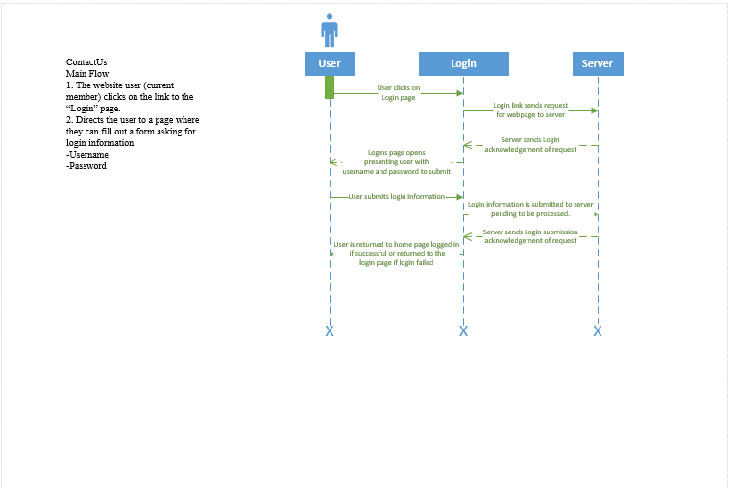

Use Case Specification: ViewBenefits

Version 1.1

Revision History

|  |  |  |  |
| --- | --- | --- | --- |
| **Date** | **Version** | **Description** | **Author** |
| 27/02/17 | 1.0 | Assignment 3 | Andrew Huff |
| 05/04/17 | 1.1 | The ViewBenefits allows a member to see which benefits are available to them. | Andrew Huff |
|  |  |  |  |
| 3 |  |  |  |

Table of Contents

1. ViewBenefits 27

1.1 Brief Description 27

1.1.1 Allows members to view benefits available to them and gives them opportunities to fill out requests to use those benefits. 27

2. Flow of Events 27

2.1 Basic Flow 27

2.1.1 The use case begins when the member is logged into their KY HBPA account. 27

2.1.2 The member clicks on “Benefits” within their user account. 27

2.1.3 The member is presented with the list of benefits that KY HBPA provides. 27

2.2 Alternative Flows 27

3. Special Requirements 27

3.1 None 27

4. Pre-conditions 28

4.1 The member must have an online account. 28

4.2 The member must be logged into their online account. 28

5. Post-conditions 28

5.1 The member is provided with a list of benefits that KY HBPA provides. 28

6. Extension Points 28

6.1 FileAClaim 28

Use Case Specification: ViewBenefits

# Use-Case Name

## Brief Description

### Allows members to view benefits available to them and gives them opportunities to fill out requests to use those benefits.

# Flow of Events

## Basic Flow

### The use case begins when the member is logged into their KY HBPA account.

### The member clicks on “Benefits” within their user account.

### The member is presented with the list of benefits that KY HBPA provides.

# Special Requirements

## No special requirements necessary.

# Pre-conditions

## The member must have an online account.

## The member must be logged into their online account.

# Post-conditions

## The member is provided with a list of benefits that KY HBPA provides.

# Extension Points

## FileAClaim

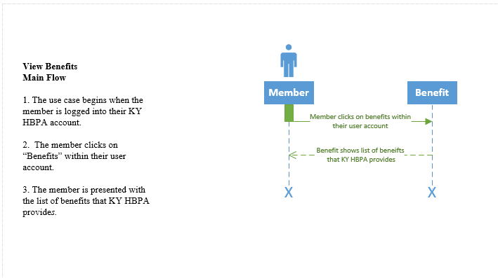

SubmitForms

Version 1.1

Revision History

|  |  |  |  |
| --- | --- | --- | --- |
| **Date** | **Version** | **Description** | **Author** |
| 07/03/17 | 1.0 | Use Case for Submitting forms | Jordan Gates |
| 05/04/17 | 1.1 | Use Case for Submitting forms | Jordan Gates |
|  |  |  |  |
| 4 |  |  |  |

Table of Contents

1. SubmitForms 33

1.1 Brief Description 33

2. Flow of Events 33

2.1 Basic Flow 33

2.2 Alternative Flows 33

2.2.1 Mailing Forms 33

2.2.2 Turning in forms in person 33

3. Special Requirements 334

4. Pre-conditions 334

4.1 Scanner or Camera 334

4.2 Connection 334

5. Post-conditions 334

5.1 The file is submitted 334

Use Case Specification: SubmitForms

# SubmitForms

## Brief Description

The system will allow for the ability to submit forms. The user selects the submit a form box in the section that he needs to submit to. Then he or she is prompted to browse the computer for a file to submit. The user then submits a picture of his form from a camera or scanner.

# Flow of Events

## Basic Flow

This use case begins as the member clicks on the “Submit a Form” button. This will prompt him or her to select a file from their phone or computer. The member then submits a picture from their camera or scanned from their scanner. The file is then submitted to the data base for their membership file.

## Alternative Flows

### Mailing Forms

If the member cannot submit the form due to the lack of a camera or scanner they can still mail in their form.

### Turning in forms in person

If the member cannot submit the form due to the lack of a camera, scanner, or mailing supplies, they can still come in person to complete their forms.

# Special Requirements

None

# Pre-conditions

## Scanner or Camera

The member must have a scanner or camera, to record the file.

## Connection

The member must have an internet connection to connect to the website.

# Post-conditions

## The file is submitted

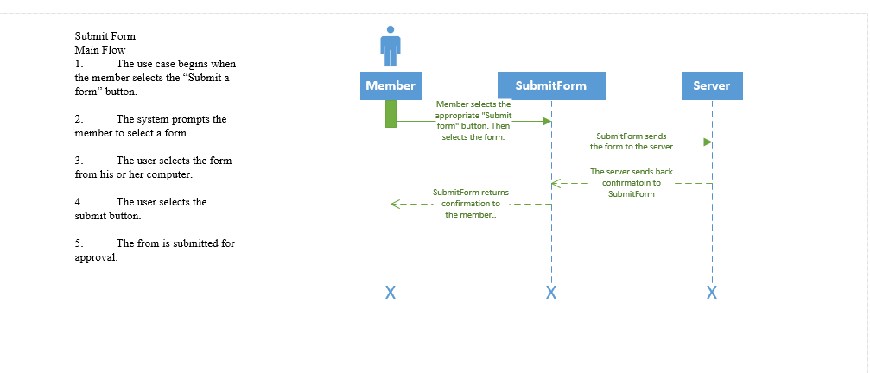

Version 1.1

Revision History

|  |  |  |  |
| --- | --- | --- | --- |
| **Date** | **Version** | **Description** | **Author** |
| 21/03/17 | 1.0 | Details of how claims will be processed | Adam Passanisi |
| 05/04/17 | 1.1 | Details of how claims will be processed | Adam Passanisi |
|  |  |  |  |
| 5 |  |  |  |

Table of Contents

1. ProcessClaims 39

1.1 Brief Description 39

2. Flow of Events 39

2.1 Basic Flow 39

2.2 Alternative Flows 39

2.2.1 User doesn’t fully fill out form before submitting it 39

### 2.2.2 User enters information in the wrong box 39

3. Special Requirements 40

3.1 < First Special Requirement > 40

4. Pre-conditions 40

# 4.1 User must be a KHBPA member 40

4.2 User must have an internet connection 40

5. Post-conditions 40

5.1 Claim is sent to the KHBPA server 40

5.2 User is sent back to the website 40

# ProcessClaims

## 1.1 Brief Description

## One of the processes for the KHBPA is to provide money to those who have to have their horse euthanized. For the money to get to the right people they need to submit claims to the KHBPA. Processing claims can be complicated but if done online, can be simplified.

# Flow of Events

## Basic Flow

* User logs onto KHBPA website
* User clicks on ‘Submit claim’ tab
* User fills out information on form
* User clicks on ‘Process claim’ button
* Claim is sent to the KHBPA

## Alternative Flows

### User doesn’t fully fill out form before submitting it.

* Error message pops up saying that form needs to be filled out

### User enters information in the wrong box

* Error message pops up saying the information entered is wrong

# Special Requirements

* None

# Pre-conditions

# User must be a KHBPA member

* User must have an internet connection

# Post-conditions

* Claim is sent to the KHBPA server
* User is sent back to the website

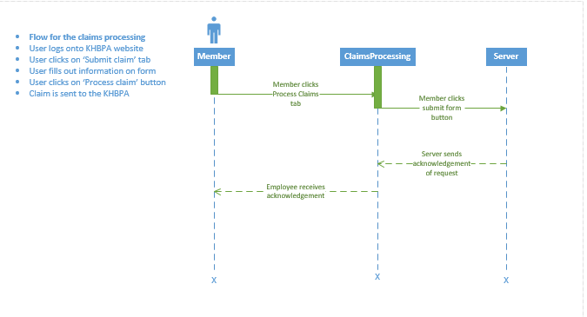

The Race to A New System

Use Case Specification: LinkToSocialMedia

Version 1.1

Revision History

|  |  |  |  |
| --- | --- | --- | --- |
| **Date** | **Version** | **Description** | **Author** |
| 27/02/17 | 1.0 | Assignment 3 | Andrew Huff |
| 05/04/17 | 1.1 | Social media can be linked to the website. | Andrew Huff |
|  |  |  |  |
| 6 |  |  |  |

Table of Contents

1. LinkToSocialMedia **Error! Bookmark not defined.**5

1.1 Brief Description 455

2. Flow of Events 455

2.1 Basic Flow 455

2.2 Alternative Flows 466

2.2.1 Facebook 466

2.2.2 Instagram 466

2.2.3 Twitter 466

3. Special Requirements 466

3.1 None 466

4. Pre-conditions 46

4.1 The member must be on the KY HBPA homepage. 46

5. Post-conditions 46

5.1 The member is routed to the KY HBPA page on the selected social media site. 46

Use Case Specification: LinkToSocialMedia

# 1. LinkToSocialMedia

## Brief Description

Links to the social media pages for the KY HBPA will be added to the main homepage for Members to click through to KY HBPA social media webpages on their respective websites.

# Flow of Events

## Basic Flow

1. The use case begins when the member clicks on one of the social media links on the KY HBPA website
2. The system routes the member to the webpage for the KY HBPA on the selected social media site.

## Alternative Flows

### Facebook

#### The alternative flow begins after step 1 of the main flow.

#### The system routes the member to the KY HBPA’s facebook page.

### Instagram

#### The alternative flow begins after step 1 of the main flow.

#### The system routes the member to the KY HBPA’s Instagram page.

### Twitter

#### The alternative flow begins after step 1 of the main flow.

#### The system routes the member to the KY HBPA’s Twitter page.

# Special Requirements

## None

# Pre-conditions

## The member must be on the KY HBPA homepage.

# Post-conditions

## The member is routed to the KY HBPA page on the selected social media site.

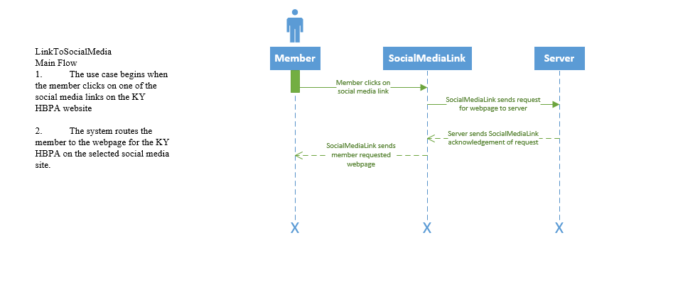

Use Case Specification: SocialMediaFeed

Version 1.1

Revision History

|  |  |  |  |
| --- | --- | --- | --- |
| **Date** | **Version** | **Description** | **Author** |
| 27/02/17 | 1.0 | Assignment 3 | Andrew Huff |
| 05/04/17 | 1.1 | The social media feed can be embedded to the website. | Andrew Huff |
|  |  |  |  |
| 7 |  |  |  |

Table of Contents

1. SocialMediaFeed 51

1.1 Brief Description 51

2. Flow of Events 51

2.1 Basic Flow 51

3. Special Requirements 51

## Requires software which can scrape applicable KY HBPA feeds 51

4. Pre-conditions 540

## Member must be on the KY HBPA Webpage 558

5. Post-conditions 540

5.1 Member is viewing the social media feed 558

Use Case Specification: SocialMediaFeed

# Use-Case Name

## Brief Description

Highlights from the various social media pages ran by KY HBPA employees will be added to a feed that will be displayed on the main homepage. The feed will be aggregated by scraping the most recent posts from the KY HBPA Facebook, Instagram and Twitter social media platforms.

# Flow of Events

## Basic Flow

### The use case begins with the member arriving at the homepage of the KY HBPA.

### The member scrolls down on the homepage where they will see a box with recent social media posts. The posts are categorized with the most recent being at the top level.

# Special Requirements

## Requires software which can scrape applicable KY HBPA feeds

# Pre-conditions

## Member must be on the KY HBPA Webpage

# Post-conditions

## Member is viewing the social media feed.

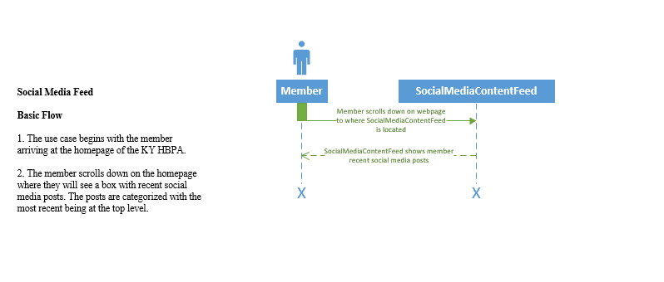

Use Case Specification: ViewPhotoGallery

Version 1.1

Revision History

|  |  |  |  |
| --- | --- | --- | --- |
| **Date** | **Version** | **Description** | **Author** |
| 22/03/17 | 1.0 | The photo gallery will allow viewers to see photos from various races or stables. | Krysta Albertson |
| 05/04/17 | 1.1 | The photo gallery can have a safety measure for allowing photos to be uploaded by users. | Krysta Albertson |
|  |  |  |  |
| 8 |  |  |  |

Table of Contents

1. ViewPhotoGallery 57

1.1 Brief Description 57

2. Flow of Events 57

2.1 Basic Flow 57

2.2 Alternative Flows 57

2.2.1 View Individual Photo 57

3. Special Requirements 58

3.1 Photo Resolution 58

4. Pre-conditions 58

4.1 Slide Show Abilility Programmed 58

5. Post-conditions 58

5.1 Pictures can be out of Focus 58

6. Extension Points 59

6.1 Upload Images 59

Use Case Specification: ViewPhotoGallery

# ViewPhotoGallery

## Brief Description

The photo gallery will allow the members and other site visitors to view photos from the track and various races. There will also be some photos submitted by members to the Kentucky Horsemen Benevolent and Protective Association to be uploaded to the site. This will also need some integration from social media photos to the website.

# Flow of Events

## Basic Flow

* A viewer of the website navigates to the homepage.
* The viewer clicks on the photo gallery tab.
* The viewer clicks start slide show.
* The slide show starts.

**2.2** **Alternative Flows**

### **2.2.1** **View Individual Photo**

If a viewer only wants to see one specific photo there should be an option to view a photo from the list without having to go through the gallery.

# Special Requirements

## Photos Resolution

The resolution can depict the quality of the photos uploaded. Some photos will be pixelated or blurry in one resolution but not another. The person uploading the photos will need to make sure every picture is using the correct resolution to ensure optimal quality.

# Pre-conditions

## Slide Show Ability Programmed

Both Visual Studio and HTML have a way you can make a photo gallery. Wix.com, a website builder, has a built in photo gallery option where you get to choose which photo gallery format the website will have.

# Post-conditions

## Pictures can be out of Focus

If the picture’s resolution is not compatible with the website, or the resolution could be better, zooming in on the photo can make the photo out of focus. In addition, zooming in a photo would allow a user to see the details in a picture better.

# Extension Points

## 6.1 Upload Images

There could be the possibility of allowing members to upload their own photos to be approved for addition to the photo gallery. A few applications that can be added to a website have an algorithm that will rate the uploaded photo to ensure that it is safe to show on the website.

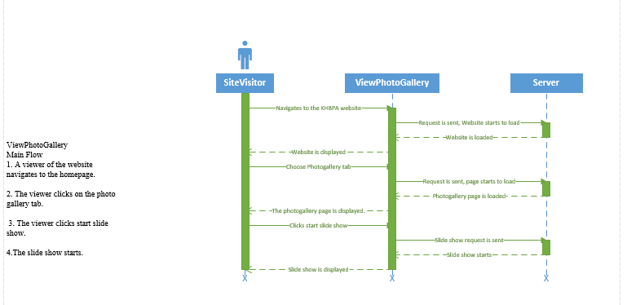

UploadImages

Version 1.1

Revision History

|  |  |  |  |
| --- | --- | --- | --- |
| **Date** | **Version** | **Description** | **Author** |
| 20/03/17 | 1.0 | Use Case for uploading images | Jordan Gates |
| 05/04/17 | 1.1 | Use Case for uploading images | Jordan Gates |
|  |  |  |  |
| 9 |  |  |  |

Table of Contents

1. UploadImages 664

1.1 Brief Description 664

2. Flow of Events 664

2.1 Basic Flow 664

2.2 Alternative Flows 664

2.2.1 Mailing pictures 664

2.2.2 Turning in pictures in person 65

3. Special Requirements 65

4. Pre-conditions 65

4.1 Scanner or Camera 65

4.2 Connection 65

5. Post-conditions 65

5.1 The picture is submitted 65

Use Case Specification: UploadImages

# 

# 1.UploadImages

## Brief Description

The system will allow for the ability to upload images. The user selects the submit a form box in the section that he needs to submit to. Then he or she is prompted to browse the computer for a file to submit. The user then submits a picture of his form from a camera or scanner.

# 2.Flow of Events

## Basic Flow

* This use case begins as the member clicks on the “Submit an Image” button.
* This will prompt him or her to select a file from their phone or computer.
* The member then submits a picture from their camera or scanned from their scanner.
* The file is then submitted to the data base for their membership file.

## Alternative Flows

### Mailing pictures

If the member cannot submit the form due to the lack of a camera or scanner they can still mail in their form.

### Turning in pictures in person

If the member cannot submit the form due to the lack of a camera, scanner, or mailing supplies, they can still come in person to complete their forms.

# Special Requirements

None

# Pre-conditions

## Scanner or Camera

The member must have a web browser and internet connection to submit the file.

## Connection

The member must have an internet connection to connect to the website.

# Post-conditions

## The picture is submitted

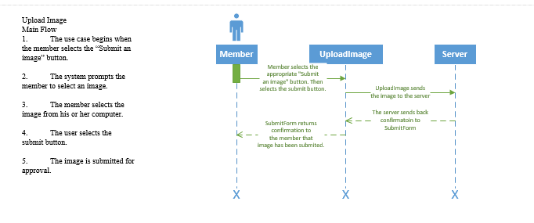

Use Case Specification: ViewCalendar

Version 2.0

Revision History

|  |  |  |  |
| --- | --- | --- | --- |
| **Date** | **Version** | **Description** | **Author** |
| 22/03/17 | 1.0 | The calendar is important to know events for the KHBPA. | Krysta Albertson |
| 05/04/17 | 2.0 | The calendar can also have events that when a user selects it, they can leave feedback. | Krysta Albertson |
|  |  |  |  |
| 10 |  |  |  |

Table of Contents

1. ViewCalendar 70

1.1 Brief Description 70

2. Flow of Events 70

2.1 Basic Flow 70

2.2 Alternative Flows 70

2.2.1 Change the View to a Different Year 70

3. Special Requirements 71

## 3.1 Details about the Event should be on Calendar 71

4. Pre-conditions 71

## 4.1 An Event Date must be known 71

5. Post-conditions 71

## 5.1 Calendar is usable 71

6. Extension Points 72

6.1 Event Feedback 72

Use Case Specification: ViewCalendar

# 1.ViewCalendar

## Brief Description

A calendar is important for an organization. If there are events or deadlines, members will need to be aware. You can say the newsletter would be sufficient but sometimes people can forget what the newsletter had said or the newsletter could have been deleted. The calendar is a daily, weekly, monthly, and even yearly view of what events are happening.

# 2.Flow of Events

## Basic Flows

* A member logs into a computer.
* The member navigates to the KHBPA sites from the browser.
* On the site homepage, there is a calendar.
* A member can click on the calendar to change the view.
* Upcoming events or deadlines will be visible.

## Alternative Flows

### 2.2.1 Change the View to a Different Year

There should be an option to change calendar date to the next year.

# Special Requirements

## Details about the Event should be on Calendar

A short description of the event and an event time should be shown on the calendar. This description should include the day, time, and location of the event. The description could also have a link in it that will bring the user to a page for tickets(if required), and information about who is conducting the event.

# Pre-conditions

## An Event Date must be known

For an event to be shown in the calendar the date will need to be known. There will not be a place in the calendar to show events that happen annually but on different dates.

# Post-conditions

## Calendar is usable

If everything is configured correctly, the calendar should be able to be viewed with different events, for different years to come.

# Extension Points

## Event Feedback

On the calendar events, there will be an option for a user to leave feedback on an event that has already happened. This will allow the KHBPA to know what participants think of events and what exactly they would like to see in future events.

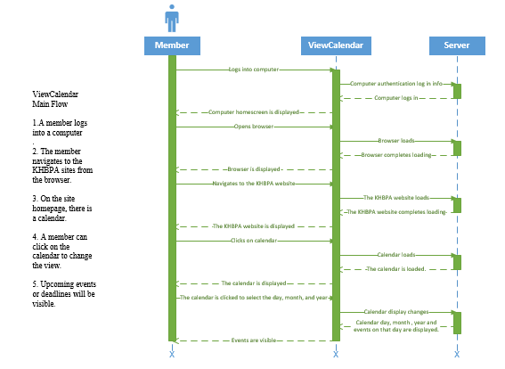

Use Case Specification: EventFeedback

Version 1.0

Revision History

|  |  |  |  |
| --- | --- | --- | --- |
| **Date** | **Version** | **Description** | **Author** |
| 01/0517 | 1.0 | Use Case for Event Feedback | Andrew Huff |
|  |  |  |  |
|  |  |  |  |
| 11 |  |  |  |

Table of Contents

1. EventFeedback 77

1.1 Brief Description 77

2. Flow of Events 77

2.1 Basic Flow 77

2.2 Alternative Flows 78

2.2.1 Invalid Email Address / Password 78

3. Special Requirements 78

3.1 None 78

4. Pre-conditions 78

4.1 A member clicks on the login button on the KY HBPA homepage. 78

5. Post-conditions 78

5.1 A member is logged into their account. 78

5.2 A member receives a bad e-mail/password message. 78

# 1. EventFeedback

## Brief Description

The user will reflect on a recent event that the KYHBPA was involved with. The user will fill out three different forms that will be submitted and reviewed by an employee.

# Flow of Events

## Basic Flow

1. Begins when user clicks on the "Calendar" tab
2. Next, the user will click on a date
   1. A list of events will appear
   2. Events that are complete will be a clickable hyperlink
3. The user will select a completed event
   1. The event feedback form will appear
4. The user will click on their level of interest (very dissatisfied- very satisfied)
5. The user will enter into the first text box their concerns with the event (if any)
6. The user will enter into the second box suggestions for improvement (if any)
7. The user will click submit to submit the form

## Alternative Flows

### User backs out of form

#### The alternative flow begins in step 4

#### The user will have entered some information

3. The user will accidentally back out of the form without submitting

# Special Requirements

## The event must be completed for the form to open

# Pre-conditions

## The event is complete

# Post-conditions

## The user receives a notification stating the form is submitted

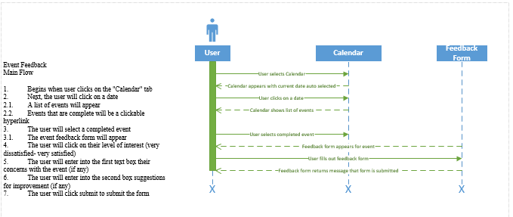

Use Case Specification: MakeADonation

Version 1.1

Revision History

|  |  |  |  |
| --- | --- | --- | --- |
| **Date** | **Version** | **Description** | **Author** |
| 01/03/17 | 1.0 | Use Case for Donations | Louis Ries |
| 05/04/17 | 1.1 | Use Case for Donations | Louis Ries |
|  |  |  |  |
| 12 |  |  |  |

Table of Contents

1. MakeADonation 83

1.1 Brief Description 83

2. Flow of Events 83

2.1 Basic Flow 83

2.2 Alternative Flows 84

2.2.1 Donate via PayPal 84

2.2.2 Donate via Credit Card 84

2.2.3 Cancel Donation 84

3. Special Requirements 84

3.1 None 84

4. Pre-conditions 85

4.1 A user clicks on the donate button on the KY HBPA homepage. 85

5. Post-conditions 85

5.1 A user has made a donation to the KY HBPA 85

5.2 A user has not made a donation to the KY HBPA 85

Use Case Specification: MakeADonation

# Use-Case Name

## Brief Description

The user will click on the donate page on the main page of the KY HBPA website. The member will be directed to a donation page made by PayPal where they have the option to make a donation with their PayPal account or a credit card.

# Flow of Events

## Basic Flow

1. The use case begins when the member selects “Donate”.
2. The system brings the user to the donation page.
3. The system gives the user an option to donate via PayPal or Credit Card
   1. If the user chooses PayPal, the system will ask them to login using their PayPal credentials
   2. If the user chooses Credit Card, the system will ask them to provide their credit card details.

## Alternative Flows

### Donate via PayPal

#### The alternative flow begins in step 3 of the main flow.

#### If the user chooses PayPal, the system will ask them to login using their PayPal credentials

### Donate via Credit Card

#### The alternative flow begins in step 3 of the main flow.

#### If the user chooses Credit Card, the system will ask them to provide their credit card details.

### Cancel Donation

#### The alternative flow begins in step 3 of the main flow.

#### If the user chooses, they can back out of the donation process by clicking on any link to go back to the KY HBPA website.

# Special Requirements

## None

# Pre-conditions

## A user clicks on the donate button on the KY HBPA homepage.

# Post-conditions

## A user has made a donation to the KY HBPA

## A user has not made a donation to the KY HBPA

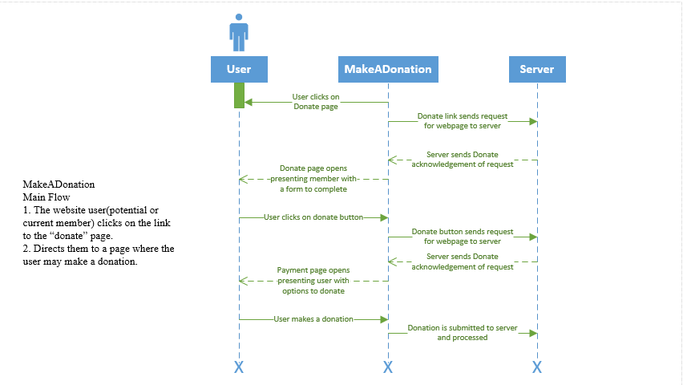

Use Case Specification: FormPayment

Version 1.1

Revision History

|  |  |  |  |
| --- | --- | --- | --- |
| **Date** | **Version** | **Description** | **Author** |
| 01/03/17 | 1.0 | Use Case for FormPayment | Louis Ries |
| 05/04/17 | 1.1 | Use Case for FormPayment | Louis Ries |
|  |  |  |  |
| 13 |  |  |  |

Table of Contents

1. FormPayment 90

1.1 Brief Description 90

2. Flow of Events 90

2.1 Basic Flow 90

2.2 Alternative Flows 91

2.2.1 Pay via PayPal 91

2.2.2 Pay via Credit Card 91

2.2.3 Cancel Payment 91

3. Special Requirements 91

3.1 None 91

4. Pre-conditions 92

4.1 A member clicks on the form submission button on the KY HBPA homepage. 92

5. Post-conditions 92

5.1 A member has made a payment to the KY HBPA 92

5.1.1 The form or report is processed. 92

5.2 A member has not made a payment to the KY HBPA 92

Use Case Specification: FormPayment

# Use-Case Name

## Brief Description

The member will click on the forms page on the main page of the KY HBPA website. The member selects a form or report to have processed. The member pays for the form or report to be processed. The form is received by the KY HBPA or the report is delivered to the member.

# Flow of Events

## Basic Flow

1. The use case begins when the member selects “Forms".
2. The system brings the member to the form page.
3. The member selects a form or report.
   1. The member chooses to submit a form.
   2. The member chooses to receive a report.
4. The member uploads or fills out all fields required for their selection.
5. The system gives the member an option to pay via PayPal or Credit Card
   1. If the member chooses PayPal, the system will ask them to login using their PayPal credentials
   2. If the member chooses Credit Card, the system will ask them to provide their credit card details.

## Alternative Flows

### Pay via PayPal

#### The alternative flow begins in step 3 of the main flow.

#### If the member chooses PayPal, the system will ask them to login using their PayPal credentials

### Pay via Credit Card

#### The alternative flow begins in step 3 of the main flow.

#### If the member chooses Credit Card, the system will ask them to provide their credit card details.

### Cancel Payment

#### The alternative flow begins in step 4 of the main flow.

#### If the member chooses, they can back out of the payment process by clicking on any link to go back to the KY HBPA website.

# Special Requirements

## None

# Pre-conditions

## A member clicks on the form submission button on the KY HBPA homepage.

# Post-conditions

## A member has made a payment to the KY HBPA

### The form or report is processed.

#### The form is submitted to the KY HBPA.

#### The report is displayed to the member.

## A member has not made a payment to the KY HBPA

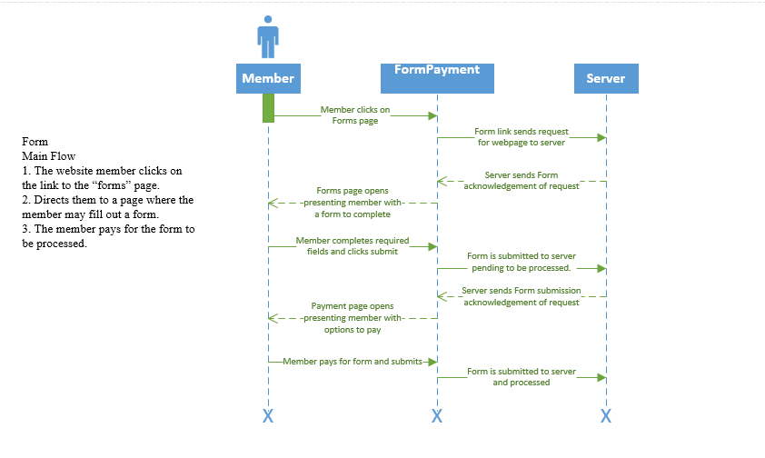

PrintForm

Version 1.1

Revision History

|  |  |  |  |
| --- | --- | --- | --- |
| **Date** | **Version** | **Description** | **Author** |
| 07/03/17 | 1.0 | Use Case for printing forms | Jordan Gates |
| 05/04/17 | 1.1 | Use Case for printing forms | Jordan Gates |
|  |  |  |  |
| 14 |  |  |  |

Table of Contents

1. PrintForm 97

1.1 Brief Description 97

2. Flow of Events 97

2.1 Basic Flow 97

2.2 Alternative Flows 97

2.2.1 Getting a form in person 97

3. Special Requirements 97

4. Pre-conditions 98

4.1 Printer 98

4.2 Connection 98

5. Post-conditions 98

5.1 The form is printed 98

Use Case Specification: PrintForm

# PrintForm

## Brief Description

# Flow of Events

## Basic Flow

* The system will allow for the ability to print forms.
* The user selects the form that is needed in the “Forms” section.
* Then the file is downloaded as a PDF to the user’s computer.
* The user then selects the print option.
* The print dialogue box is brought up and the user selects their printer.
* Then the user selects print.

## Alternative Flows

### Getting a form in person

If the member cannot print the form due to the lack of a printer, they can still come to the office and receive a form.

# Special Requirements

None

# Pre-conditions

## Printer

The member must have a printer with printing supplies to print the form.

## Connection

The member must have an internet connection to connect to the website.

# Post-conditions

## The form is printed

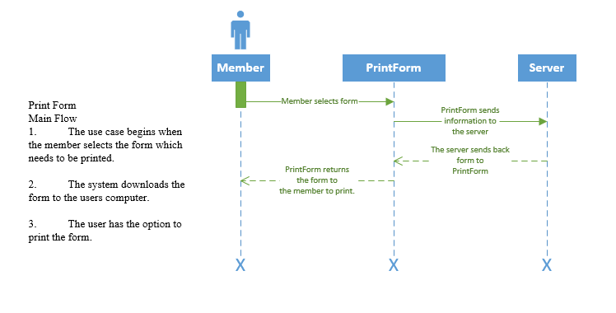

EmailNewsletter

Version 1.1

Revision History

|  |  |  |  |
| --- | --- | --- | --- |
| **Date** | **Version** | **Description** | **Author** |
| 07/03/17 | 1.0 | Use Case for Email Newsletter | Jordan Gates |
| 05/04/17 | 1.1 | Use Case for Email Newsletter | Jordan Gates |
|  |  |  |  |
| 15 |  |  |  |

Table of Contents

1. EmailNewsletter 103

1.1 Brief Description 103

2. Flow of Events 103

2.1 Basic Flow 103

2.2 Alternative Flows 103

2.2.1 Mailing News 103

3. Special Requirements 103

4. Pre-conditions 104

4.1 Subscription 104

4.2 Connection 104

5. Post-conditions 104

5.1 Email Error 104

Use Case Specification: EmailNewsletter

# EmailNewsletter

## Brief Description

The system allows the ability to send out newsletters through emails. The admin logs on to GSuite and emails the master member list, and an email is sent out to everyone in the group instantaneously.

# Flow of Events

## Basic Flow

The use case begins when the employee logs onto the GSuite account. The employee then types out the email, and sends it to the master list from their database of email addresses.

## Alternative Flows

### Mailing News

An Alternative to using the GSuite would be to hand mail their newsletters and information to everyone’s addresses. This is not recommended as it is much more expensive, and a lot of printing and mailing is involved. If a member does not have an email on file, this option may be necessary.

# Special Requirements

None

# Pre-conditions

## Subscription

The company must have a subscription to use the GSuite account.

## Connection

The company must have an internet connection to connect to GSuite.

# Post-conditions

## Email Error

On rare occasions an email might be mistyped in the database, this could cause sending errors. It is easily fixed by removing or editing the email address entered.

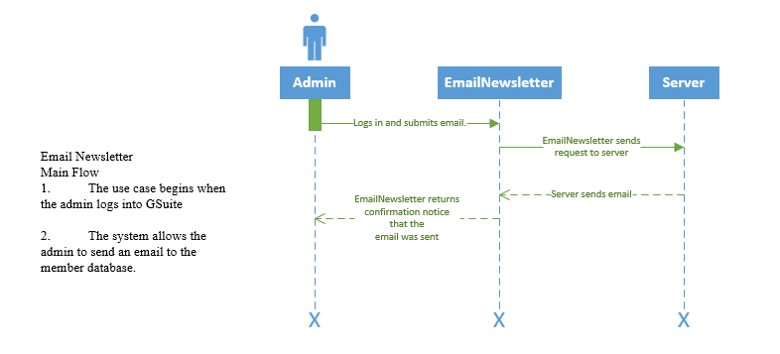

The Race to a New System

Version 1.1

Revision History

|  |  |  |  |
| --- | --- | --- | --- |
| **Date** | **Version** | **Description** | **Author** |
| 21/03/17 | 1.0 | Use case showing a member poll | Adam Passanisi |
| 05/04/17 | 1.1 | Use case showing a member poll | Adam Passanisi |
|  |  |  |  |
| 16 |  |  |  |

Table of Contents

1. MemberPoll 109

1.1 Brief Description 109

2. Flow of Events 109

2.1 Basic Flow 109

2.2 Alternative Flows 109

### 2.2.1 The user clicks the ‘submit answer’ button without selecting a choice 109

2.2.2 *The user selects an option without hitting the ‘submit answer’* 110

3. Special Requirements 110

3.1 None 110

4. Pre-conditions 110

## 4.1 Must be a KHBPA member 110

4.2 Must have an internet connection 110

5. Post-conditions 110

5.1 **The member’s answer is sent to the KHBPA server** 110

## Brief Description

In order for the website to be the most beneficial to the members, it is very important for the KHBPA to know the what the members want to see. It also important to understand how the members feel about different topics within the horse racing industry. Having a poll on the website allows the KHBPA to do this.

# Flow of Events

## Basic Flow

* The employee submits the question to the website with a certain number of answers
* The user selects the answer to the question that they see fit
* The user then sends their answer by clicking the ‘Submit answer’ button
* The answer is sent to the KHBPA server

## Alternative Flows

### The user clicks the ‘submit answer’ button without selecting a choice

* A message will pop up saying that a choice needs to be selected

### The user selects an option without hitting the ‘submit answer’ button

* Message pops up asking whether they want to save their answer or not

# Special Requirements

None

# Pre-conditions

## Must be a KHBPA member

**4.2** Must have an internet connection

# Post-conditions

## The member’s answer is sent to the KHBPA server

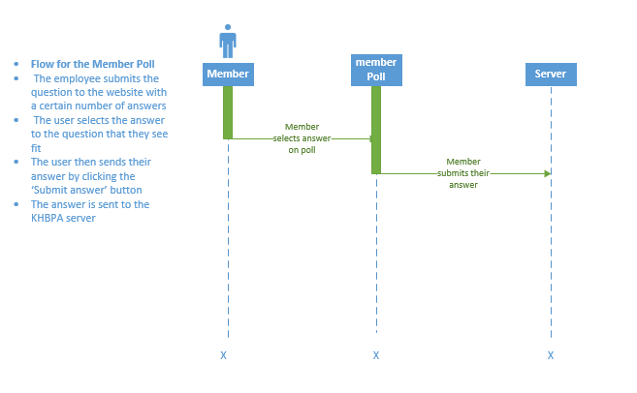

The Race to a New System

Version 1.1

Revision History

|  |  |  |  |
| --- | --- | --- | --- |
| **Date** | **Version** | **Description** | **Author** |
| 21/03/17 | 1.0 | Use case detailing a news feed for the website | Adam Passanisi |
| 05/04/17 | 1.1 | Use Case detailing a news feed for the website. | Adam Passanisi |
|  |  |  |  |
| 17 |  |  |  |

Table of Contents

1. NewsFeed 115

1.1 Brief Description 115

2. Flow of Events 115

2.1 Basic Flow 115

2.2 Alternative Flows 116

2.2.1 < First Alternative Flow > 116

2.2.2 < Second Alternative Flow > 116

3. Special Requirements 116

3.1 None 116

4. Pre-conditions 116

4.1 Employee must be connected to the internet 116

4.2 Employee must be on a different website 116

5. Post-conditions 116

## 5.1 The KHBPA website will now receive updates from the different horse racing websites that they are subscribed to 116

6

# News Feed

## Brief Description

Members of the KHBPA need to be up to date on what is happening around the state and country within the horse racing industry. It is vital that they receive a constant update of news and information throughout the industry. Members of the KHBPA will receive the most up-to-date information with a news feed.

# Flow of Events

## Basic Flow

* KHBPA employee visits website that deals with horse racing
* The employee clicks the subscribe button on the website
* The subscribe button sends the request to the website server
* The website is updated
* Server sends alert to aggregator
* Aggregator sends alert to the KHBPA website with summary of update

## Alternative Flows

### The employee hits the subscribe button accidently

* The employee just has to click the unsubscribe button and will stop receiving updates from the website

# Special Requirements

None

# Pre-conditions

## 1. Employee must be connected to the internet

4.2 2. Employee must be on a different website

# Post-conditions

## The KHBPA website will now receive updates from the different horse racing websites that they are subscribed to

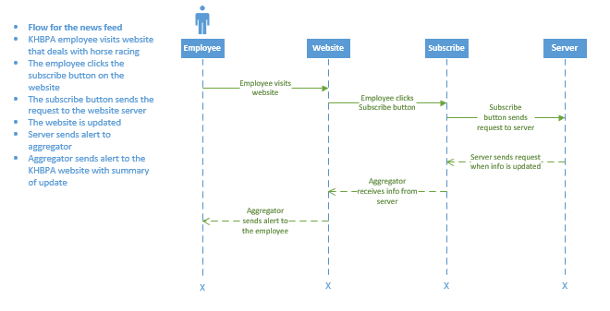

The Race to a New System

Version 1.1

Revision History

|  |  |  |  |
| --- | --- | --- | --- |
| **Date** | **Version** | **Description** | **Author** |
| 21/03/17 | 1.0 | Use case detailing a page with Employee information | Adam Passanisi |
| 05/04/17 | 1.1 | Use case detailing a page with Employee information | Adam Passanisi |
|  |  |  |  |
| 18 |  |  |  |

Table of Contents

1. EmployeeInfoPage 121

1.1 Brief Description 121

2. Flow of Events 121

2.1 Basic Flow 121

2.2 Alternative Flows 1391

### 2.2.1 Member leaves the employee page 1571

2.2.2 . Member exits out of the web browser 12148

3. Special Requirements 1240

3.1 None 1258

4. Pre-conditions 1240

## 4.1 Member must be connected to the internet 1258

4.2 Member must be on the KHBPA website 122

5. Post-conditions 1240

## 5.1 The employee info page is returned to the member 1258

# Employee Info Page

## Brief Description

It is very important for members to be able to contact the employees of the KHBPA at any time about any important information or issues. Having an employee information page allows for employee information to be in one, centralized place that is easy for members to have access to.

# Flow of Events

## Basic Flow

* Member visits KHBPA website
* Member clicks on ‘Employee Info’ tab
* Tab sends request to server
* Server returns employee info page to the member

## Alternative Flows

### 1. Member leaves the employee page

* Member is returned to the previous page that were on

#### 2. Member exits out of the web browser

# Special Requirements

None

# Pre-conditions

## Member must be connected to the internet

4.2 Member must be on the KHBPA website

# Post-conditions

## The employee info page is returned to the member

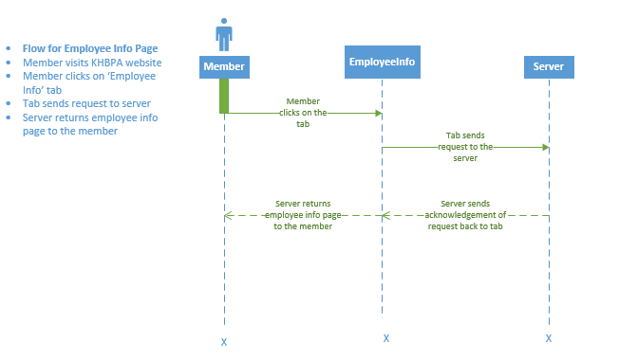

The Race to A New System

Version 1.1

Revision History

|  |  |  |  |
| --- | --- | --- | --- |
| **Date** | **Version** | **Description** | **Author** |
| 28/02/2017 | 1.0 | Assignment 3 | William Phelps |
| 05/04/17 | 1.1 | The use case for a contact us page | William Phelps |
|  |  |  |  |
| 19 |  |  |  |

Table of Contents

1. Contact us via Website 127

1.1 Brief Description 127

2. Flow of Events 127

2.1 Basic Flow 127

2.2 Alternative Flows 127

2.2.1 Contacting Outside the Form 127

3. Special Requirements 127

3.1 None 127

4. Pre-conditions 128

4.1 Connection

4.2 On KYHBPA Website 128

5. Post-conditions 128

5.1 Message Sent 128

# Contact us via Website

## Brief Description

New users and current members most-likely want to have an easy way to get ahold of the company, in order to ask questions, make comments or for any other number of reasons. While they may call on their own schedule, when it works for them, it may not be the best time for an employee to respond. Some customers may email which allows for a response when available, it makes more sense to try and have all these comments, questions, etc. to come in, in the same format. That is the goal of the “Contact us via Website” form.

# Flow of Events

## Basic Flow

The website user (current member or potential member) clicks on the link to the “Contact us” page. This will direct them to a page where they can fill out a form asking for basic information such as: name, subject, how to contact, and most importantly, the message they wish to send.

## Alternative Flows

### Contacting Outside the Form

Though, this option should allow most messages to be received in this way, some users will still contact via phone or email. Having a public phone number and email will allow this to happen, though it most-likely could not be stopped completely, this option should help.

# Special Requirements

None

# Pre-conditions

## Connection

The user must also have a working Internet connection, to connect to the cloud.

## On KYHBPA Website

The user must be on the website and on the “Contact us” page.

# Post-conditions

## Message Sent

If all pre-conditions are met, and the form is filled out, the message along with the other information will be sent to the KYHBPA and allowed to be responded to when time allows.

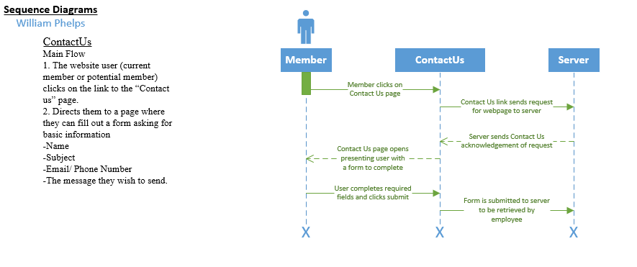

Use Case Specification: MobileLayout

Version 1.1

Revision History

|  |  |  |  |
| --- | --- | --- | --- |
| **Date** | **Version** | **Description** | **Author** |
| 01/03/17 | 1.0 | Use Case for MobileLayout | Louis Ries |
| 05/04/17 | 1.1 | Use Case for MobileLayout | Louis Ries |
|  |  |  |  |
| 20 |  |  |  |

Table of Contents

1. MobileLayout 133

1.1 Brief Description 133

2. Flow of Events 133

2.1 Basic Flow 133

2.2 Alternative Flows 133

2.2.1 Override Layout 133

3. Special Requirements 134

3.1 None 134

4. Pre-conditions 134

4.1 The browser window is smaller than the desktop version of the page can properly display. 134

5. Post-conditions 134

5.1 A user may use their mobile device to interact with the website. 13134

5.2 Each page on the website is accessible to mobile users. 13134

5.3 The system performs the alike functionality as the desktop version of the website. 13134

Use Case Specification: MobileLayout

# Use-Case Name

## Brief Description

The user accesses the KY HBPA website with a mobile device or a browser window smaller than the desktop version of the website can properly display.

# Flow of Events

## Basic Flow

1. The use case begins when the member enters the page on a mobile device.
2. The system displays to the user a mobile-friendly version of the home page.
3. The system continues to display mobile-friendly versions of each page as the user navigates the website.

## Alternative Flows

### Override Layout

#### The user chooses to switch to desktop view through the website.

#### The user chooses to switch to desktop view through their browser settings.

# Special Requirements

## None

# Pre-conditions

## The browser window is smaller than the desktop version of the page can properly display.

# Post-conditions

## A user may use their mobile device to interact with the website.

## Each page on the website is accessible to mobile users.

## The system performs the alike functionality as the desktop version of the website.

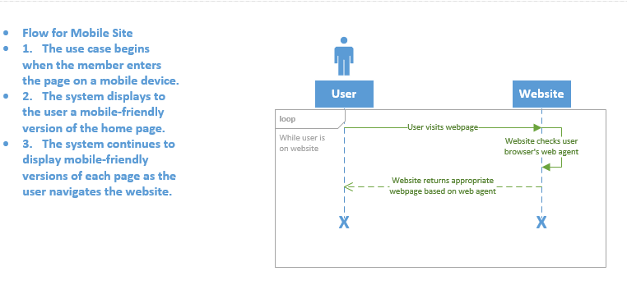

Use Case Specification: ManageMemberAccount

Version 2.0

Revision History

|  |  |  |  |
| --- | --- | --- | --- |
| **Date** | **Version** | **Description** | **Author** |
| 22/03/17 | 1.0 | Managing member accounts will allow the KHBPA to know which members are active in the current season. | Krysta Albertson |
| 05/04/17 | 2.0 | The member account can be deleted or reinstated. | Krysta Albertson |
|  |  |  |  |
| 21 |  |  |  |

Table of Contents

1. ManageMemberAccount 139

1.1 Brief Description 139

2. Flow of Events 139

2.1 Basic Flow 139

2.2 Alternative Flows 139

2.2.1 Delete Member 139

3. Special Requirements 140

3.1 The Admin must have Privileges 140

4. Pre-conditions 140

4.1 Member must be in the Database 140

5. Post-conditions 141

5.1 Member Account is still Active 141

5.2 Member Account is Deleted 141

5.3 Member Account is Reinstated 141

ManageMemberAccount

# ManageMemberAccount

## Brief Description

As of right now, there is not a system that allows the Kentucky Horsemen Benevolent and Protective Association (KHBPA) to see which members are active. With a user account database, the Kentucky Horsemen Benevolent and Protective Association will be able to easily track which members have registered for races and those members whom are in the Unites States for the season. The admin of the system can manage a user account by monitoring it, checking for information discrepancies, and deleting accounts.

# Flow of Events

## Basic Flow

* Azure admin will look into the SQL database to see members.
* The admin will see if this member has a recent login to the website.
* The admin will see if this member’s forms for the season are turned in.

## Alternative Flows

### **Delete Member**

A member is created when they sign up on the website. A member status can be active or inactive. Sometimes a member may no longer be a horse racer, owner or trainer. If they are not a racer, trainer or owner and no longer wish to be a member in the future, they can contact the KHBPA to say they are no longer a member. If they are no longer a member, their account should be deleted. To delete the member the admin will need to delete the member’s information and their profile from the database.

# Special Requirements

## The Admin must have Privileges

If the Admin does not have certain privileges, they may not be able to delete a member. If the admin does not have, the privileges a super admin will have to first give them permissions to delete member accounts.

The admin may also not have access to all the member’s files and details.

## A member archive is needed on the database

If the member is deleted by accident, the database will need an archive. Once a member is deleted their information will stored in the archive database. If a member was deleted accidently, they can be reinstated. Once reinstated the data from the archive database will be moved back to the regular member database.

# Pre-conditions

## Member must be in the Database

To view the member’s information, the member must be in the database. If the member has not correctly signed up for membership on the website, their membership in the database is null.

# Post-conditions

## Member Account is Still Active

If the member is participating in the current season, they will stay active in the database. If the member is not participating in the season their status will show as inactive but they will stain obtain membership.

## Member Account is Deleted

If the admin deleted the member, either on purpose or by accident, the member will need to contact the KHBPA to be reinstated. Once it is deleted, the information will be sent to the archive database for unenrolled members. If the member was not supposed to be deleted, they will need to be reinstated.

## Member Account is Reinstated

If the member’s account was deleted by accident, or if they decide they do want to be a member after requesting to be deleted from the KHBPA’s records, they will need to be reinstated. A member can be reinstated by the admin going to the archive database and moving the member’s information back into the member database.

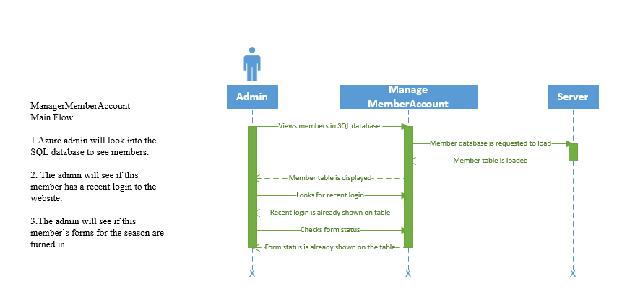

Version 1.1

Revision History

|  |  |  |  |
| --- | --- | --- | --- |
| **Date** | **Version** | **Description** | **Author** |
| 27/02/17 | 1.0 | The system needs to be able to recover from disasters by using the information from the backup method. | Krysta Albertson |
| 22/03/17 | 1.1 | Changes were made to the main flow. | Krysta Albertson |
|  |  |  |  |
| 22 |  |  |  |

Table of Contents

1. Recovery 147

1.1 Brief Description 147

2. Flow of Events 147

2.1 Basic Flow 147

2.2 Alternative Flows 148

2.2.1 Recover Data on the Same Device 148

2.2.2 Instant Restore 148

3. Special Requirements 148

3.1 Windows Machine 148

3.2 Azure Remote App 149

4. Pre-conditions 149

4.1 Backup Method Must Be Implemented 149

5. Post-conditions 149

5.1 The Data is Restored 149

5.2 Verify Data Integrity 149

5.3 The Process was Canceled 149

6. Extension Point 150

6.1 The Recovery can be made from a Backup 150

6.2 Recovery of the website 150

# Recovery

## Brief Description

The recovery option will allow the Kentucky Horseman Benevolent and Protective Association to recover or regain any lost data from the cloud service in case of an emergency. Many companies can have a technical issue and be down anywhere from hours to days. With a recovery option, such as backing information up to the proposed Azure cloud system, the downtime in a state of emergency would be minimal.

# Flow of Events

## Basic Flow

* The employee or Azure Admin will login to the Resource ManagerMicrosoft Azure Backup application*.*
* From the Resource Manager the employee or Azure admin will choose recover.
* Then they will chose the server (the machine data is being recovered on).
* Then they will browse for files.
* Then they will chose the recovery date.
* Then they will select items to recover.
* Then they will specify the location.
* Then click confirm.
* Close the Resource Manager.

## Alternative Flows

### **2.2.1 Recover Data on an Alternate Device**

To recover the data to an alternate device you go through the same steps as the basic flow. Instead of choosing this server, the user will choose the option that says another server.

### **Instant Restore**

The instant restore restores data on the same machine you are wishing to recover the data from. You can choose individual files and they are mounted. After it mounts, you can copy the files from the windows file explorer and then paste them to the desktop or any files on the machine the recovery is taking place on. Then you will need to unmount the data files in the application.

# Special Requirements

## Windows Machine

Microsoft Azure is a Microsoft product so a windows machine is the most commonly used to restore or recover data on.

## Azure Remote Application

Azure does have an option to restore or recover data to a non-windows machine that is running Linux. To achieve this you will need to download and set up the Azure Remote App. There was no information about being able to restore data to a Mac, however, if a Mac is the only available machine you can install VMware and have a virtual windows machine inside the Mac.

# Pre-conditions

## Backup Method must be implemented

In order to restore or recover the data you will need to verify that Azure has been implemented and configured correctly within the snap in application in the company Azure portal.

# Post-conditions

## The Data is Restored

If the process is completed the chosen data will be restored to the machine in the location previously selected.

## Verify Data Integrity

After recovering data from a machine, review the data to make sure that it is correct and that there is no corrupt data such as data missing or a file not being read.

**6. Extension Points**

**6.1 The Recovery can be made from a Backup**

Once a backup is made on a machine that data can be used to recover the machine later on. If the user accidently deleted something and emptied the trashcan on a computer, a recovery of that item would be simple. The user can go to the backup of the machine and select the item you deleted. Then all the user would have to do is copy the item onto a flash drive and move the item over to their machine.

**6.2 Recovery of the website**

Microsoft Azure also offers different recovery applications besides the Resource Manager. Some of the other recovery applications are made specifically for storing and recovering a backup of a website in case a disaster strike the domain. Azure site recovery is simple to use and allows fail-over and disaster recovery in Azure’s cloud.

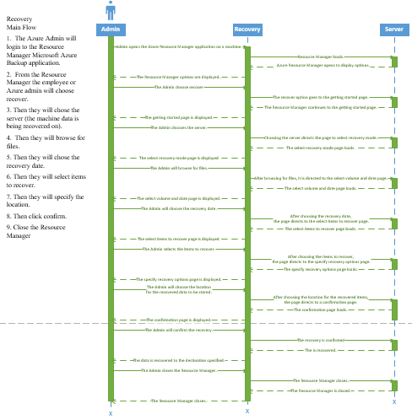

The Race to A New System

Version 1.1

Revision History

|  |  |  |  |
| --- | --- | --- | --- |
| **Date** | **Version** | **Description** | **Author** |
| 28/02/2017 | 1.0 | Assignment 3 | William Phelps |
| 05/04/017 | 1.1 | This is the use case for backup. | William Phelps |
|  |  |  |  |
| 23 |  |  |  |

Table of Contents

1. Backup 155

1.1 Brief Description 155

2. Flow of Events 155

2.1 Basic Flow 155

2.2 Alternative Flows 155

2.2.1 Not saving to the cloud 155

3. Special Requirements 155

3.1 None 155

4. Pre-conditions 156

4.1 Subscription

4.2 Connection

5. Post-conditions 156

5.1 File Saved 156

# Backup

## Brief Description

An integral part of any businesses continuity plan needs to include a consideration for offsite data backup, in the event of a disaster that could damage or corrupt data held onsite. The idea is that data held in a cloud storage system is easily accessible and also safer than being held solely on an onsite server or as hard copies.

# Flow of Events

## Basic Flow

The employee initiates this case by saving something from a computer to the cloud.

When an employee wishes to save something from their machine, they will upload a copy to the cloud to be saved.

## Alternative Flows

### Not Saving to Cloud Storage

An alternative to saving to the cloud storage system would be to save directly to the employee computer. Though this is not recommended as it takes away the added safety of the cloud, it is still a possible route to take.

# Special Requirements

None

# Pre-conditions

## Subscription

The company must have a subscription to use the services of a cloud storage system.

## Connection

The user must also have a working Internet connection, to connect to the cloud.

# Post-conditions

## File Saved

If all pre-conditions are met, the file being saved should be successfully saved to the cloud for safe storage.

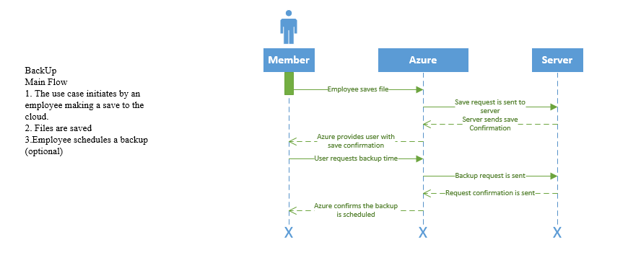

**Class Diagram:**

The class diagram describes the relationships that we have discovered between the various objects in our use cases.  The diagram acts as a pseudo entity relationship diagram because it gives us insight into how our entities should be designed for our database.

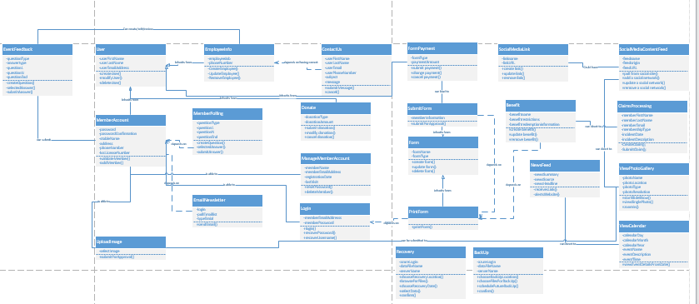

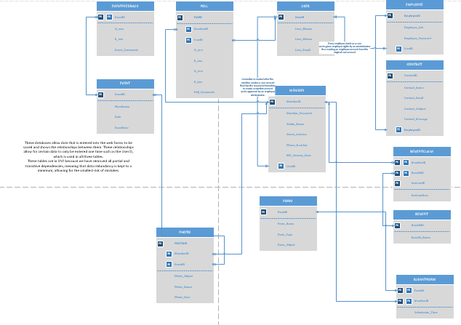

These databases allow data that is entered into the web forms to be saved and shows the relationships between them. These relationships allow certain data to only be entered one time such as the UserID, which is used in all three tables.

These tables are in 3NF because we have removed all partial and transitive dependencies, meaning that data redundancy is kept to a minimum, allowing for the smallest risk of mistakes.

**Database Definitions:**























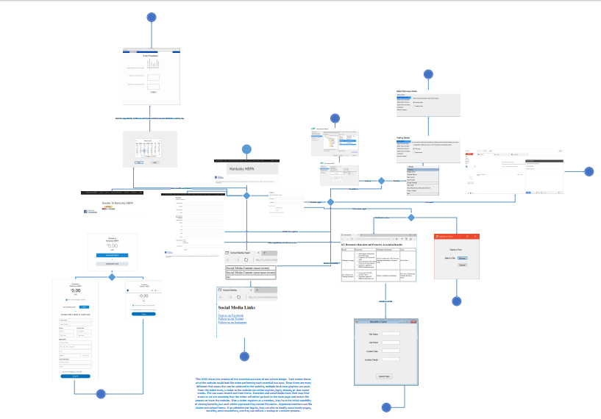

This WND shows the process of the essential use cases of our system design. Each screen shows what the website could look like when performing each essential use case. Since there are many different final states that can be achieved in the website, multiple final state graphics are used. From the initial state, a visitor to the website can either register, login, donate, or view social media. The use cases branch out from there. Donation and social media have their own final states as we are assuming that the visitor will either go back to the main page and restart the process or leave the website. One a visitor registers as a member, they have the initial capability of viewing benefits, but until admin approved they cannot file claims. Approved members can file claims and upload forms. If an administrator logs in, they are able to modify social media pages, benefits, send newsletters, and they can initiate a backup or a restore process.



Recovery

A business can find itself in a disaster moment that crashes their entire system.

To recover the website for the KHBPA, Microsoft Azure site recovery can be used to recover the website itself. Microsoft Azure Resource Manager, as stated in the use cases, can be used for machine recoveries. Azure Site Recovery for customer owned sites costs $16 per month per instance of recovery protected. Azure Site Recovery to Azure sites costs 25 per month per instance of recovery protected. The site recovery is free for the first 30 days. According the Datto recovery analysis tool at the 500GB of data the KHBPA has, the downtime for two days would be $10,000.

Backups

Depending on the site domain used when producing the system will be a deciding factor in how the system can be backed up. WordPress has backup instructions online for their website. The application you can use on WordPress is called the UpdraftPlus WordPress Backup Plugin. Also, Wix has site history where you can see all changes made to the website created there. At any time, you can recovery to a previous version.

Encryption

Microsoft Azure has a few options for encryption. For the site data, the Azure Storage Service Encryption can be used. This will automatically encrypt the data prior to storage and decrypt it prior to retrieval. It does encrypt Azure Resource Manager. Azure also includes transparent data encryption of the SQL database server.

|  |  |  |
| --- | --- | --- |
| Type of Requirement | Definitions | Examples |
| System Value Estimates | This is the estimated business value of the system and its data. | Downtime would cost about $5000 a day. |
| Backup Requirements | What needs to be backed up on the system, how often it should be backed up, the time it should be backed up, and what is going to be used to backup the system. | A backup should be scheduled every week through WordPress allowing for data integrity. |
| Recovery Requirements | What is going to be used to recover the system and how the recovery is initiated. | The system goes down, and through WordPress an old backup is recovered. |
| Encryption Requirements | Defines what data will be encrypted and what will be used to encrypt the data. | Data will be encrypted in order to keep safe from those without authentication to view. |

**Gantt Chart:**

The Gantt Chart is a tool used to schedule when a deliverable item should be done to stay on track with the iterations. In this Gantt chart, we had a break between a few of the different tasks so there was room for slack time. Every iteration ended on the appropriate date. With May 2nd being the end of the elaboration specification.

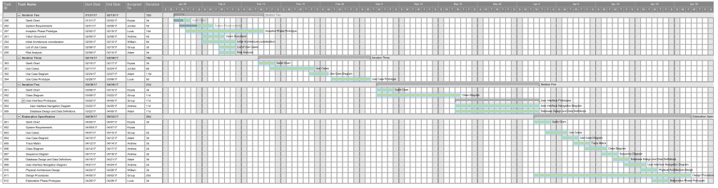

**Elaboration Specification Prototypes:**

To register a user would need to enter the information, which the KYHBPA requires along with a digital signature.

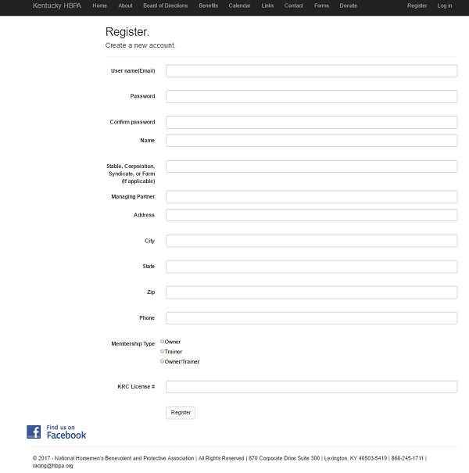

 To login a user would need to provide their username (e-mail address) and password.

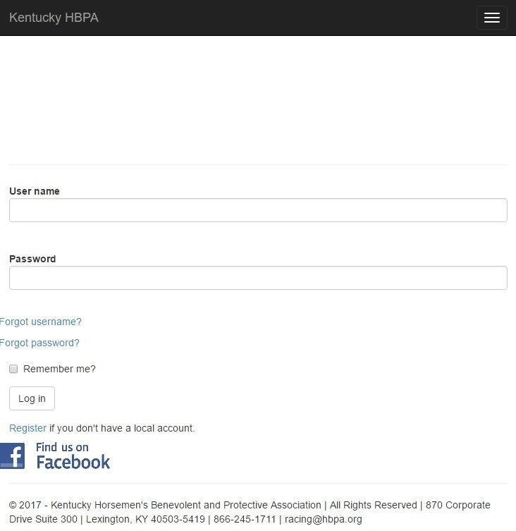

A user can view the benefits that KYHBPA provides them on this page along with a link to file a claim for said benefit.

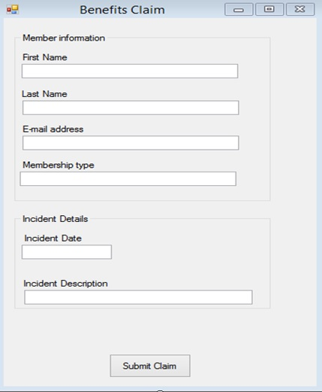

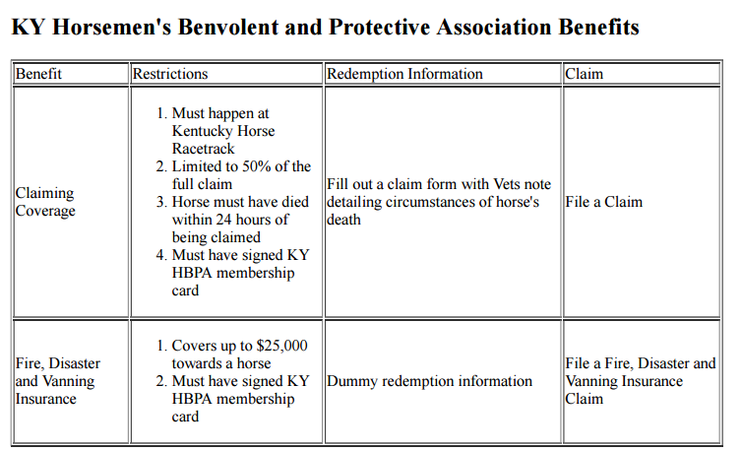

 A user can submit a form for a KYHBPA employee to review.

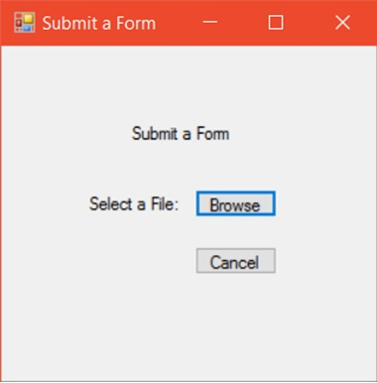

To claim benefits a member would need to enter their first and last name and the incident date and details.   
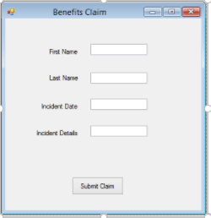

A user can click through to all the social media platforms for which KYHBPA has a presence.

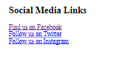

 A user can view all the most recent posts made by KYHBPA on various social media platforms.



The photo gallery will allow users of the site to view either the individual photos or start a slide show of the photos in the gallery.



A user can upload an image of their own choosing to be vetted by a KY HBPA employee for inclusion to the media gallery.



The calendar will allow a member to click on a date to view an event.

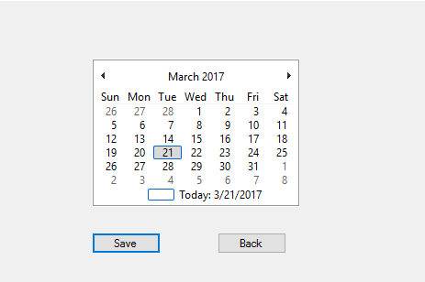



To provide feedback a member would need to choose a value based on a 7-point scale from Very Dissatisfied to Very Satisfied.  They could then provide suggestions for improvements and what they liked about the event.

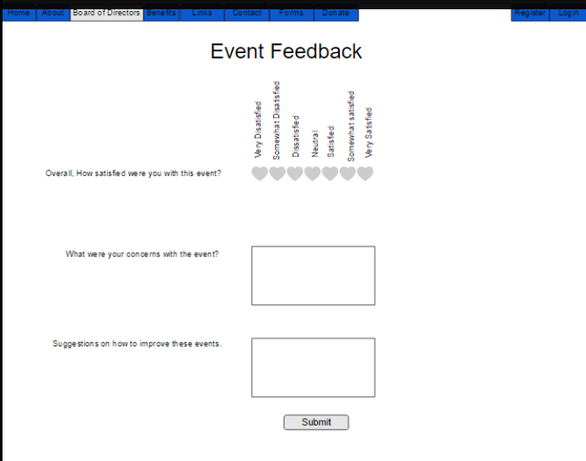

This is what a user would see when attempting to make a donation online.

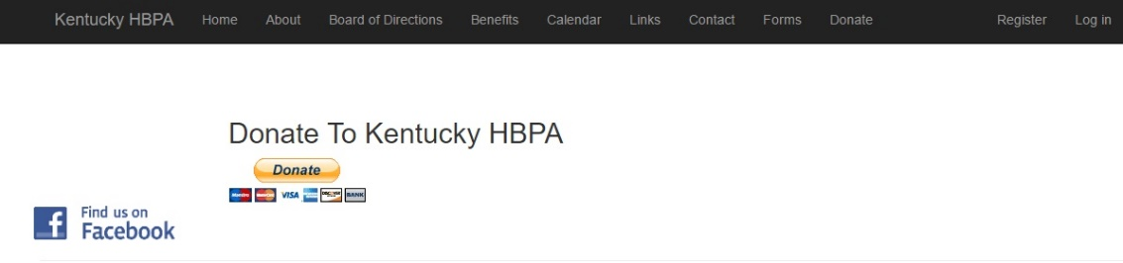

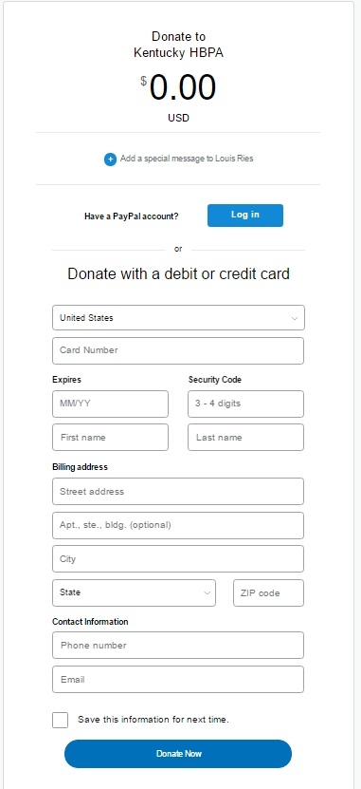

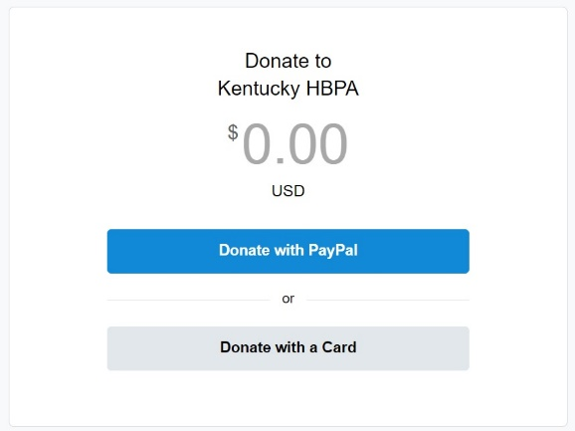

A user can use PayPal to pay for an online form

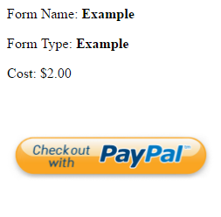

A user can use PayPal to pay for an online form.

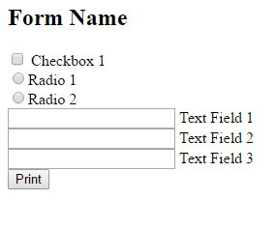

A KYHBPA employee can submit a newsletter to all registered users on their mailing list.

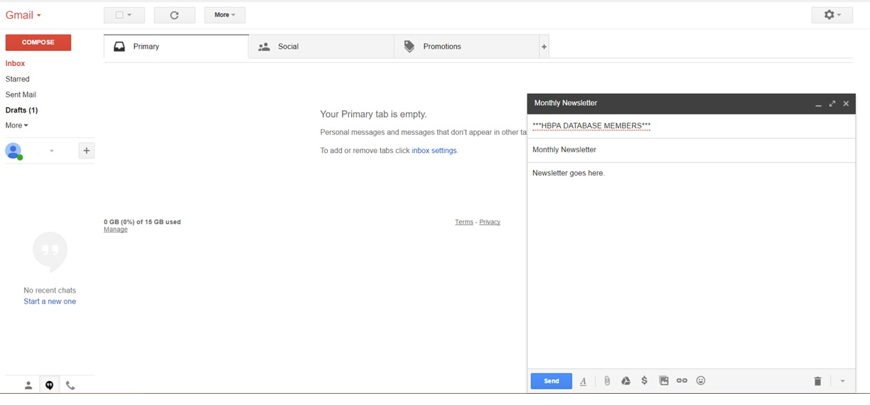

This is a vague prototype of what the member poll will look like. The amount of answers does not need to be limited to four choices. You can have as many as you see fit.

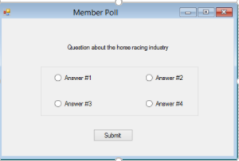

The KHBPA can disseminate news on their website using a news feed.

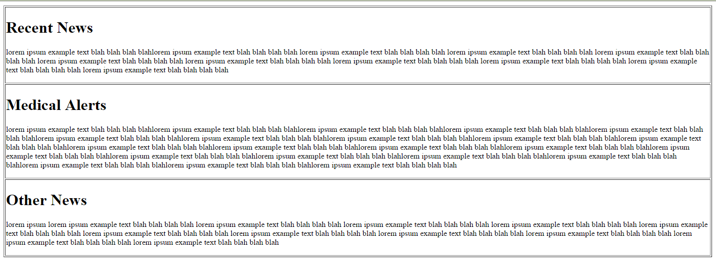

This is an example of how the board of directors or the employee information page could look.

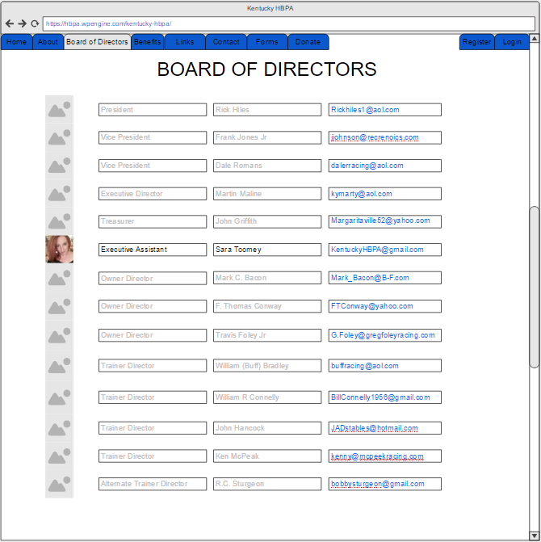

 A user can input their name and e-mail address along with a subject and message for KYHBPA staff to answer.

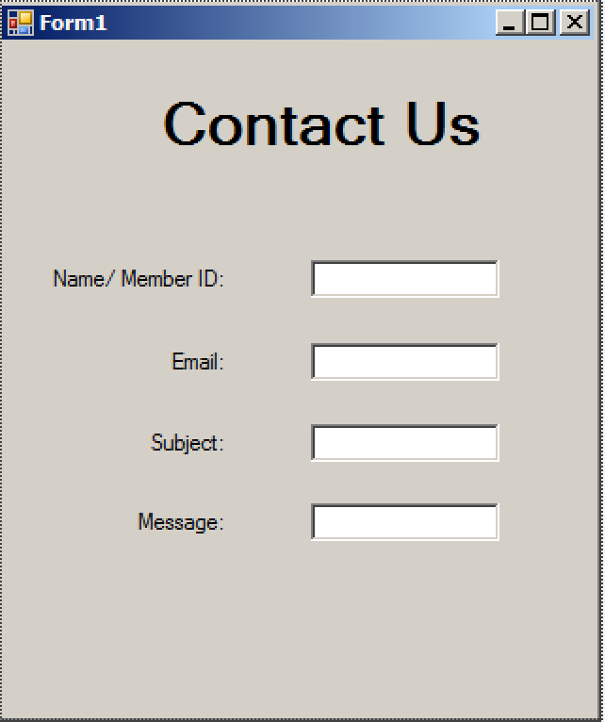

The mobile website could look something like this.



This is an example of what the admin might see while managing users.

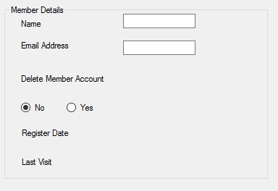

This is an example of the resource manager interface used for recovery.

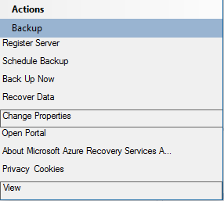

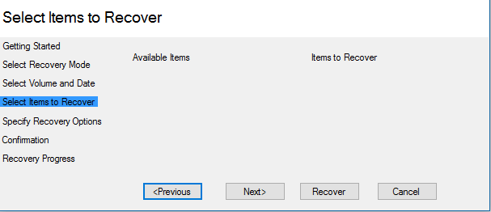

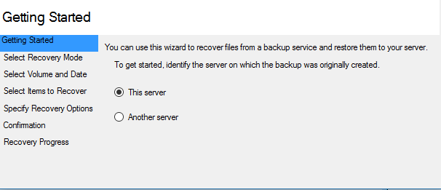

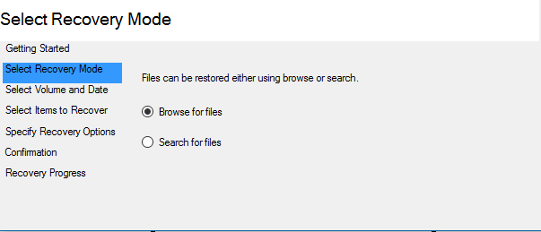

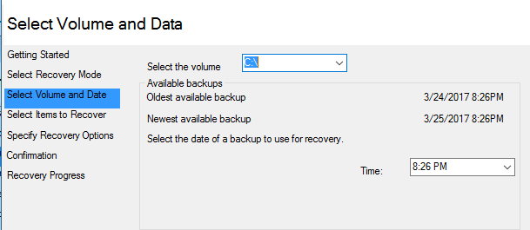

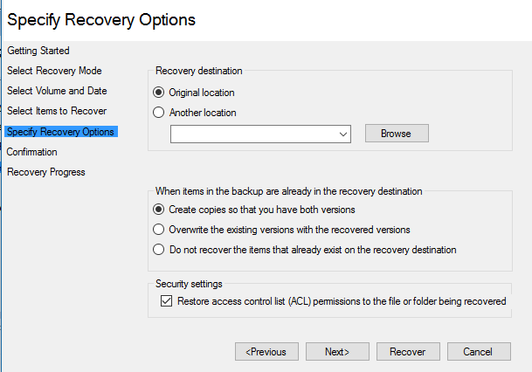

This is what a system administrator would need to do to initiate and manage backups

